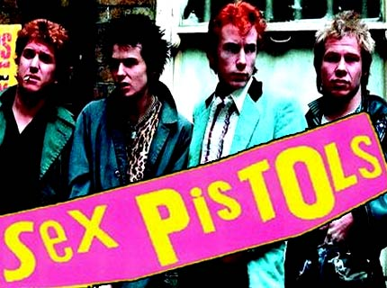
Taking a look at today’s alternative rock scene, questioning of past influences comes into play. Most of today’s bands claim to have grown up listenting to the Sex Pistols, The Clash, The Ramones, and so on. The introduction of punk in the 80’s were these groups main influences. However, after a quick comparison of lyrics that does not seem to be the case.
Today’s bands song of heart-break and relationship problems with a catchy riff or beat. It’s not a negative quality in a band, it’s just not Sex Pistols or Clash-ish. For example, the Sex Pistols classic hit, “God Save The Quuen”, was a rebellious, anti-government anthem that has continued to egg on generations of youth. On the other hand, a band that has evolved into a mainstream band, The Matches, create songs based on moral lessons and problems within one self, with the occasional relationship song. The lyrics are not on the same playing field which can confuse just about anyone.
These bands that have created such a phenomenal genre in rock deserve to have band re create their lyrics with just as much rage and emotion. Instead we

only have about three amazing stick-it-to-the-government bands and they do not get played on the radio. It’s teagic that the fans of today’s mainstream music do not even give a seconds thought to the idea of an anarchy band. Instead they listen to the same sounding music.
Now, don’t insert words that were never there. The music of today is amazing and emotional and the artists are geniouses. It would just be a little bit better if we had more anti-law bands.
The lyrics from “God Save The Queen” and “Papercut Skin” can be related but
the rebellion is missing. In the Matches’ song, the human race and its faults are assaulted. Proclaiming that the human race is filled with heartless, cruel people is an important message but will never capture the independence and rebellion that “God Save The Queen” brought to the music scene back in 1977.

“God Save The Queen” Lyrics

God save the Queen
Her facist regime
They made you a moron
Potential h-bomb
God save the Queen
She ain't no human being
There's no future
In England's dreaming
Don't be told what you want
Don't be told what you need
There's no future, no future
No future for you
God save the Queen
We mean it man
We love our Queen
God saves
God save the Queen
'Cos those tourists are money
And our figure head
Is not what she seems
Oh God save history
God save your mad parade
Oh Lord God have mercy
All crimes are paid
When there's no future
How can there be sin
We're the flowers in the dustbin
We're the poison in the human machine
we're the future, your future
God save the Queen
We mean it man
We love our Queen
God saves
God save the Queen
We mean it man
And there's no future
In England's dreaming
No future (x3)
For you
No future (x3)
For me
No future (x3)
For you
No future, no future
For you

“Papercut Skin” Lyrics

Day out, day in
It's the alarm versus me
and the snooze button wins.
I've been waking all my life
to become what I'm going to be.
I'm a crone, la da da da da da
A headstone
Day out, day in
and begin again
Day out, day in
recycle bins
cash out, cash in
debit pins
day out, day in
the paper cuts my skin again
skin again
Cash out, cash in
I can burn all I earn
on some weakness or whim
without thinking
I'm a mark for their marketing plans
I'm Americancer
A Myspace romancer
Cash out, cash in
and begin again
Day out, day in
recycle bins
Cash out, cash in
debit pins
Day out, day in
the paper cuts my skin again
skin again
Day out, day in
Vitamins
give out, give in
Vicodins
Day out, day in
the paper cuts my skin again
skin again
skin again
skin again
All ye, all ye, come home free
Olly Olly oxen free
Day in, day out
I call time out
All ye, all ye, come home free
Olly Olly oxen free
Day in, day out
I call time out
I call time out
Give out, give in
If a man's hands show his trade does it suit me then
This papercut skin that makes me wince with each hand
I'm required to
shake, shake, shake, shake
Day out, day in
recycle bins
cash out, cash in
debit pins
Day out, day in
the paper cuts my skin again
skin again
Day out, day in
Vitamins
give out, give in
Vicodins
Day out, day in
the paper cuts my skin again
skin again
skin again
skin again
I call time out
Olly Olly oxen free

The lyrics are distinctive and the difference is remarkable. Both artists have produced meaningful lyrics that will carry on over the years. The major difference is the amount of time. The Sex Pistols have carried on for over thirty years, and the matches song has been forgotten by some. Which song will people remember thirty years from now? Only time will tell.

